FESTIVAL INVITATION
44th National Chevrolet Festival (Post Covid - Take 2!!)
Yarrawonga Victoria.
Friday 22nd- Monday 25th October 2021
“G’DAY BOWTIES” !!!!!!

Based on the overwhelming success of the Remark Festival in November 2019, it has been proven the National event is certainly ‘alive and well’ and the Chevrolet Club of Victoria Inc. is honoured to host this 44th National Chevrolet Festival rescheduled from 2020 to now take place in October 2021.
As announced in Renmark, this is the first time we have dipped our foot in the water for many years and our Festival Committee is going all out to make this a “pearler”. We therefore would like to extend an invitation to all of your members and associates to join us in celebrating this year’s 44th term of ‘OUR’ National Festival.
The Dates are.. 22nd and 25th of October 2021 in beautiful Yarrawonga / Mulwala
Yarrawonga is a perfect choice!! It has more sunshine than the Gold Coast (we are told!), It has great access for all people travelling from all areas of Oz, it has many attractions, great drives, excellent accommodation and that wonderful lake unique to this location.
The famous SHOW AND SHINE will be held around the picturesque foreshore on our own expansive grassed area with the magnificent waterway as a backdrop. To the right we will be complimented with a huge Sunday Farmers Market plus direct access to town and to our left the historic Paddle Steamers moored out front waiting to take you on another journey…..now you would have to agree that’s hard to beat.
Further, our committee has gone all out and secured a very special venue for the auspicious ‘Presentation Dinner’ that will well exceed all expectations at the newly upgraded Club Mulwala resort. But, the best part is the club is delighted to have us there and it has been secured at better than reasonable cost that will surely delight everyone and undoubtedly meet the National Guidelines of ensuring this an ‘affordable’ and ‘fun’ festival to all entrants!!
Page: 1
Sadly, we unexpectedly lost a key committee member and dedicated long term festival attendee in Mr Peter Mantel during 2020. We will of course be appropriately honouring his contributions to the National Festival at the dinner presentations, particularly for those who knew Peter well over many years of associating with such a nice guy.
FESTIVAL INVITATION

We have some great runs planned and special destinations arranged just for you that are unique to this wonderful region or, you can just chill out!!
There is also a host of accommodation choices in Yarrawonga and Mulwala ranging from relaxed camping/social venues to motels and resort style clubs to B&B’s with everything in between.
Our Centre of operations is THE YARRAWONGA HOLIDAY PARK
https://www.yarrawongaholidaypark.com.au/ Ph: 03 5744 2331
This venue is already heavily booked based on the success of Renmark in addition to the Festivals 12 month Covid delay. They are hugely experienced in car event management playing hosts to the Annual Lake Mulwala Hot Rod festival that attracts some 600+ cars.
CHEVY AVE will be just on the left as you drive in and will be well and truly signposted. Our welcoming BBQ and registration will also be here and it’s easy walking distance to town.
Look them up, the site is massive, clean, secure, kid friendly and well run by the Driscoll team
The committee is recommending accommodation alternatives with the local tourist bureau who have been excellent in supporting all our event arrangements. Always call and quote ‘National Chev Festival’ as bookings are blocked out for us and to obtain a discounted pricing. Three points however…
- Club Mulwala (RSL) is fantastic and newly renovated. They have set aside 48 very large motel style rooms with wonderful views for us but… they won’t last if you dilly dally! https://www.clubmulwala.com.au/ Ph: 03 5744 2331
- If you still want a cabin and park style accommodation, BIG4 NRMA Yarrawonga Mulwala Holiday Park also offers plenty of cabin and caravan site accommodation, plus if you mention you’re staying as part of the event you’ll save 20% on your stay with NRMA Members saving a further 5%*, or if booking online visit https://www.nrmaparksandresorts.com.au/special-offers/national-chevrolet-festival/
- Yarrawonga/Mulwala has other extensive accommodation options but get in quick as it is also a large Golfing & Water Sport destination. In doing so, please utilise the local Yarrawonga/Mulwala Tourist Bureau as it keeps ‘fresh money’ in town and your booking fees ‘don’t go overseas’!! https://www.yarrawongamulwala.com.au/ Ph: 03 5744 1989
Sponsors are our best friends!! We already have graciously secured a major sponsor with the RACV in addition to being wholeheartedly welcomed by the local Yarrawonga community that is simply fantastic to put this year’s festival ‘on the road’ to ensure it will be another great and fun festival from the outset.
We already have many ‘die hard’ colleagues coming from as far as W.A. and North Queensland so all we need now is your Chev and most importantly… you!! It is the only way to ensure the best time and fun filled experience is enjoyed by all and this 44th festival is another huge success under “our” National Chevrolet Festival banner!!!!!
Page: 2 2
FESTIVAL INVITATION
Now… To the nuts and bolts……….
Festival Committee Members at your disposal are
CRAIG O, DONOHUE 0402 064 993 IAN COLE 0419 534 765
DAVID SHAW 0419 892 684 MICHAEL JOHNSON 0403 678 113
RON BAKER 0421 599 229 PATRICK PRUSAKOWSKI 0427 992 287
Finally, the President of the Victorian Branch Keith Taylor 0421 287 350
(Now Bro and Bro-ettes please only contact Keith with glowing positive feedback.)

Festival Email Contact chevfest2021@chevcarclubvic.org.au

Web Contact Points
Chevrolet Car Club of Victoria Inc. http://www.chevcarclubvic.org.au/ https://www.facebook.com/CCCVI/
National Chevrolet Festival https://www.facebook.com/National-Chevrolet-Festival-Australia
Yarrawonga Tourist Information Centre https://www.yarrawongamulwala.com.au/
Yarrawonga Holiday Park https://www.yarrawongaholidaypark.com.au/
Club Mulwala RSL https://www.clubmulwala.com.au/
BIG4 NRMA Yarrawonga Mulwala Holiday Park https://www.nrmaparksandresorts.com.au/yarrawonga-mulwala/
Watch the websites.. We will be regularly updating you with our ‘Signpost’ articles. Already up to No.3!!

Registration commences 8 am Friday 22nd October 2021 LETS SEE YOU THERE !!!!!!!!!!!
The Festival Application Form and Festival Program is enclosed
Sincere regards..

Your 44th Festival Committee
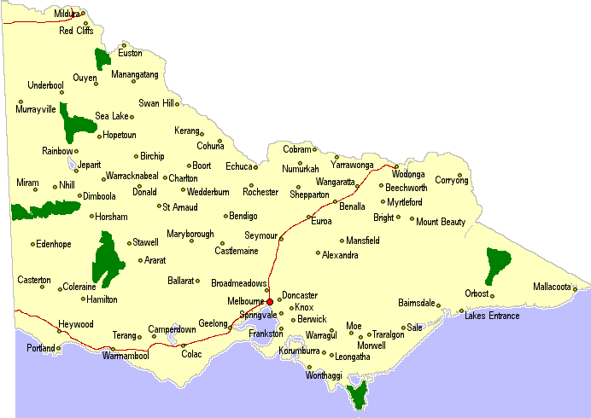

Page: 3
Yarrawonga – Victoria
(Mulwala NSW)
Melbourne, 281km/3:32 hrs Sydney, 647km/6:55 hrs,
Adelaide, 790km/8:18 hrs Brisbane, 1403km/15:00 hrs
Nth. Qld. Unbelievable!! Perth Incredible!!
Albury 93km/1:05 hrs Echuca 132 km/1:30 hrs
Beechworth 90km/1:05 hrs Bright 133 km/1:35 hrs
Euroa 112km/1:14 hrs Tassie – Across the waters!

