

YARRAWONGA & MULWALA ACCOMMODATION

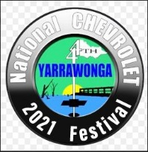

**HOLIDAY SEASONAL RATES**

**High/ Peak - January, Long Weekends (Includes both NSW & VIC Labour Day weekends), Easter, Christmas (from the Friday before Christmas to the end of January)**

**Mid/ Shoulder - February, March, April, May, September, October, November, December**

**Low/ Off Peak - June, July, August**

**CARAVAN PARKS**

[**Ingenia Holidays Sun Country**](https://www.yarrawongamulwala.com.au/ingenia-holidays-sun-country)**-** Swimming Pool & Pet Friendly

Tocumwal Road & Corowa Road, Mulwala (03) 5743 1074

[**Bundalong Holiday Resort**](https://www.yarrawongamulwala.com.au/bundalong-holiday-resort)– Swimming Pool

7419A Murray Valley Hwy, Bundalong (03) 5726 8600

[**DC on the Lake**](https://www.yarrawongamulwala.com.au/dc-on-the-lake)– Pet Friendly

3327 Spring Drive, Mulwala (03) 5744 1393

[**Big 4 NRMA Yarrawonga Mulwala Holiday Park**](https://www.yarrawongamulwala.com.au/big4-nrma-yarrawonga-mulwala-holiday-park)– Swimming Pool

102 Corowa Road, Mulwala (03) 5743 2888

[**Ski Club Holiday Park**](https://www.yarrawongamulwala.com.au/ski-club-holiday-park)

Melbourne Street, Mulwala (03) 5744 1050

[**Yarrawonga Holiday Park**](https://www.yarrawongamulwala.com.au/yarrawonga-holiday-park)– Pet Friendly (Non Peak)

Cnr Piper & Burley Road, Yarrawonga (03) 5744 3420

[**Yarrawonga Riverlands**](https://www.yarrawongamulwala.com.au/yarrawonga-riverlands-tourist-park) **–** Pet friendly ALL YEAR ROUND

38 Brears Road, Yarrawonga (03) 5744 2461

[**Yarrawonga Westside Caravan Park**](http://www.yarrawongamulwala.com.au/companies/650/37/Yarrawonga-Westside-Caravan-Park.html#/accom/66256) **-** Swimming Pool

254 Murray Valley Hwy, Yarrawonga (03) 5744 3314

**MOTELS**

[**Ashliegh Court Motor Inn**](https://www.yarrawongamulwala.com.au/ashleigh-court-motor-inn) – Swimming Pool

36 Corowa Road, Mulwala 1800 188 879

**Belmore Motor Inn**

14 Belmore Street, Yarrawonga (03) 5744 3685

**Central Motor Inn**

111 Belmore Street, Yarrawonga (03) 5744 3817

[**Capricorn Motor Inn**](https://www.yarrawongamulwala.com.au/capricorn-motor-inn) – Swimming Pool

255 Melbourne Street, Mulwala (03) 5744 3813

[**Lakeveiw Mote**l](https://www.yarrawongamulwala.com.au/lakeview-motel)– Swimming Pool

1 Hunt Street, Yarrawonga (03) 5744 1555

[**Burkes Hotel Motel**](https://www.yarrawongamulwala.com.au/burkes-hotel-motel)

96 Belmore Street, Yarrawonga (03) 5744 3033

[**Lake Mulwala Hotel Motel**](https://www.yarrawongamulwala.com.au/lake-mulwala-hotel-motel)

88 Melbourne Street, Mulwala (03) 5744 2499

[**Mulwala Resort**](https://www.yarrawongamulwala.com.au/mulwala-resort) – Swimming Pool

211 Melbourne Street, Mulwala (03) 5744 1245

[**Paradise Palms Motel Mulwala**](https://www.yarrawongamulwala.com.au/paradise-palms-motel-mulwala)–Swimming Pool

119- 121 Melbourne Street, Mulwala (03) 5743 2555

[**Yarrawonga Quality Motel**](https://www.yarrawongamulwala.com.au/yarrawonga-quality-motel)

51 Telford Street, Yarrawonga (03) 5744 1956

**Ski Land Motel**

Murray Valley Hwy, Woodlands (03) 5744 3937

**HOLIDAY HOUSES**

[**Anchorage Lakehouse**](https://www.yarrawongamulwala.com.au/anchorage-lakehouse) – Swimming Pool

87 Anchorage Way, Yarrawonga (03) 5744 1989*

[**Belair House**](https://www.yarrawongamulwala.com.au/belair-house)

20 Anchorage Way, Yarrawonga (03) 5744 1989*

[**Belle Rose**](https://www.yarrawongamulwala.com.au/belle-rose) **–** Swimming Pool

68-72 Corowa Rd, Mulwala (03) 5744 1989*

[**Bella Vita**](https://www.yarrawongamulwala.com.au/bella-vita)

39 Ely Street, Yarrawonga (03) 5744 1989*

[**Sundance Holiday Houses**](https://www.yarrawongamulwala.com.au/sundance-holiday-house)

7 Savernake Road Mulwala (03) 5744 1989*

[**Waterfront Holiday Houses**](https://www.yarrawongamulwala.com.au/waterfront-holiday-houses) **–** Swimming Pools

Various locations (03) 5744 0197

[**Waterview Woodlands**](https://www.yarrawongamulwala.com.au/waterview-woodlands)– On the lake

60 Stevenson Court, Yarrawonga (03) 5744 1989*

**HOTELS**

[**Burkes Hotel Motel**](https://www.yarrawongamulwala.com.au/burkes-hotel-motel)

96 Belmore Street, Yarrawonga (03) 5744 3033

[**The Royal Mail Hotel**](http://www.yarrawongamulwala.com.au/companies/696/39/The-Mail-Hotel.html#/accom/61269)

123 Melbourne Street, Mulwala (03) 5744 1989*

**Current 04/05/2019**

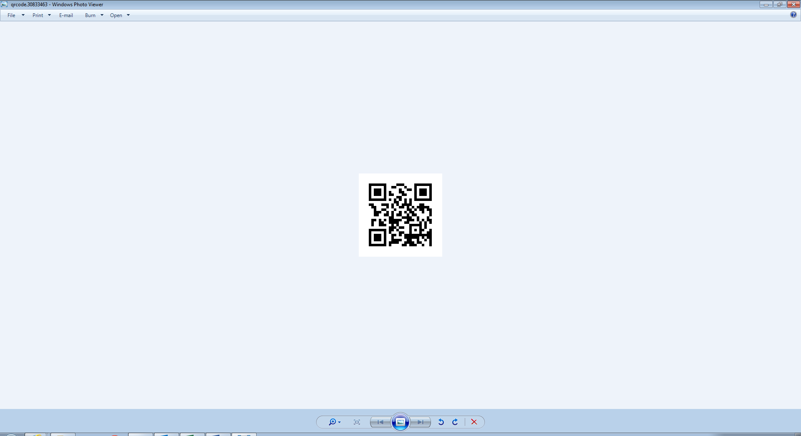

**QR Scan Code**

**yarrawonga_mulwala_info_center**

#visitsuncountryonthemurray #visityarrawongamulwala

#lakemulwala

**https://www.facebook.com/yarrawongamulwalatourism**

**RURAL SETTING/ RETREAT**

[**Airtree Golfers Resort**](https://www.yarrawongamulwala.com.au/accommodation/airtree-golfers-resort) –Swimming pool

623 Murray Valley Hwy, Yarrawonga (03) 5744 1994

**BED & BREAKFAST**

[**Lakeside @ Witts End**](https://www.yarrawongamulwala.com.au/lakeside-witts-end)

Unit 2A 2-4 Doc Court, Yarrawonga 0438 800 203

**HOLIDAY UNITS & APARTMENTS**

[**Arnie's Place**](https://www.yarrawongamulwala.com.au/arnies-place)

2/17 Bank Street, Yarrawonga (03) 5744 1989*

[**DBJ Holiday Units**](https://www.yarrawongamulwala.com.au/dbj-holiday-units)– Swimming pool

62- 66 Corowa Road, Mulwala 03 5744 1989*

[**Lakeside @ Witt's End**](https://www.yarrawongamulwala.com.au/lakeside-witts-end)

Unit 2a 2-4 Doc Court, Yarrawonga (03) 5744 1989*

[**Mul-Haven**](https://www.yarrawongamulwala.com.au/mul-haven)

208-210 Melbourne Street, Mulwala (03) 5744 1989*

[**Mul-Melba**](https://www.yarrawongamulwala.com.au/mul-melba)

208-210 Melbourne Street, Mulwala (03) 5744 1989*

[**Mulara Holiday Units**](https://www.yarrawongamulwala.com.au/mulara-holiday-units)

208-210 Melbourne Street, Mulwala (03) 5744 1989*

[**Murray Grange Villa 2**](https://www.yarrawongamulwala.com.au/murray-grange-villa-2)– Swimming Pool

21-23 Bank Street, Yarrawonga (03) 5744 1989*

[**Murray Grange Villa 4**](https://www.yarrawongamulwala.com.au/murray-grange-villa-4)– Swimming Pool

21-23 Bank Street, Yarrawonga (03) 5744 1989*

[**St Andrew Close**](https://www.yarrawongamulwala.com.au/st-andrews-close)

1/33 Melbourne Street, Mulwala (03) 5744 1989*

[**The Coop**](https://www.yarrawongamulwala.com.au/the-coop)

1/90 Telford Street, Yarrawonga (03) 5444 1989*

[**Tin Shack**](https://www.yarrawongamulwala.com.au/tin-shack)- Pet Friendly

1/28 Hunt Street, Yarrawonga (03) 5744 1989*

[**Villa Cristal 4**](https://www.yarrawongamulwala.com.au/villa-cristal-4) – Swimming Pool

4/39 Anchorage Way, Yarrawonga (03) 5744 1989*

[**Villa Crystal 1**](https://www.yarrawongamulwala.com.au/villa-crystal-1) – Swimming Pool

1/39 Anchorage Way, Yarrawonga (03) 5744 1989*

**Villa Tarni Apartments** [**13**](https://www.yarrawongamulwala.com.au/villa-tarni-apartment-13)**,** [**16**](https://www.yarrawongamulwala.com.au/villa-tarni-apartment-16)**,** [**18**](https://www.yarrawongamulwala.com.au/villa-tarni-apartment-18)**,** – Swimming Pool

212 Melbourne Street, Mulwala (03) 5744 1989*

**Recommend**